3.5.1 Warm Up - Using Bivariate Data in Context Card Sort
Cut the following cards apart. Then, match the variables to the scatter plot you think they best fit. Be prepared to explain your reasoning.
Graph Cards | Variable Cards
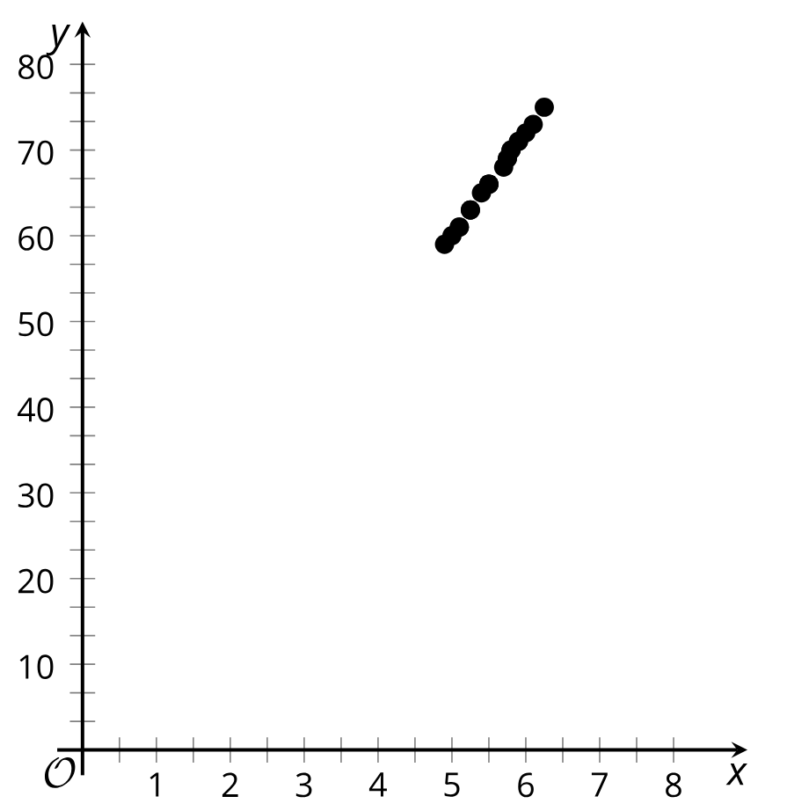 | $$x - variable:$$  Daily low temperature in Celsius  for Denver, CO  $$y - variable:$$  Boxes of cereal in stock at a grocery  in Miami, FL
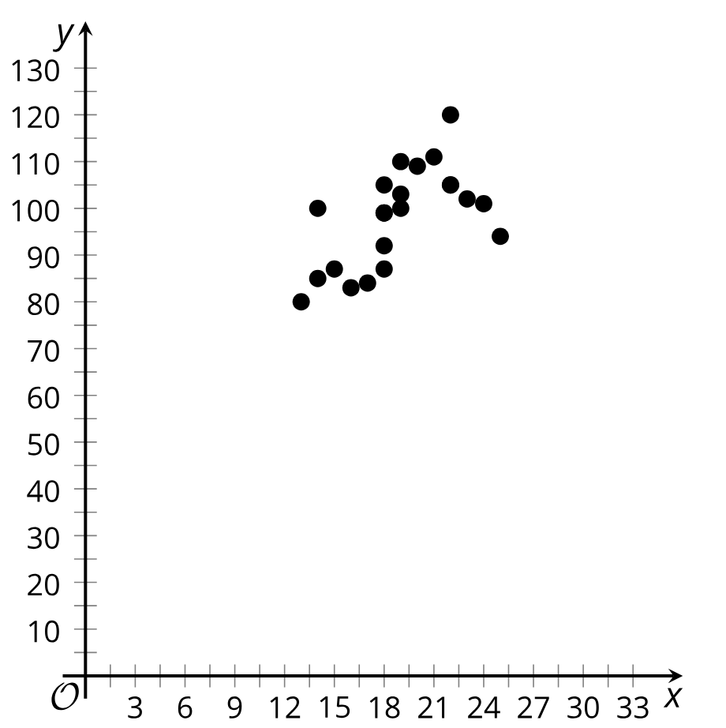 | $$x - variable:$$  Average number of free throws  shot in a season  $$y - variable:$$  Basketball team score per game

Graph Cards | Variable Cards
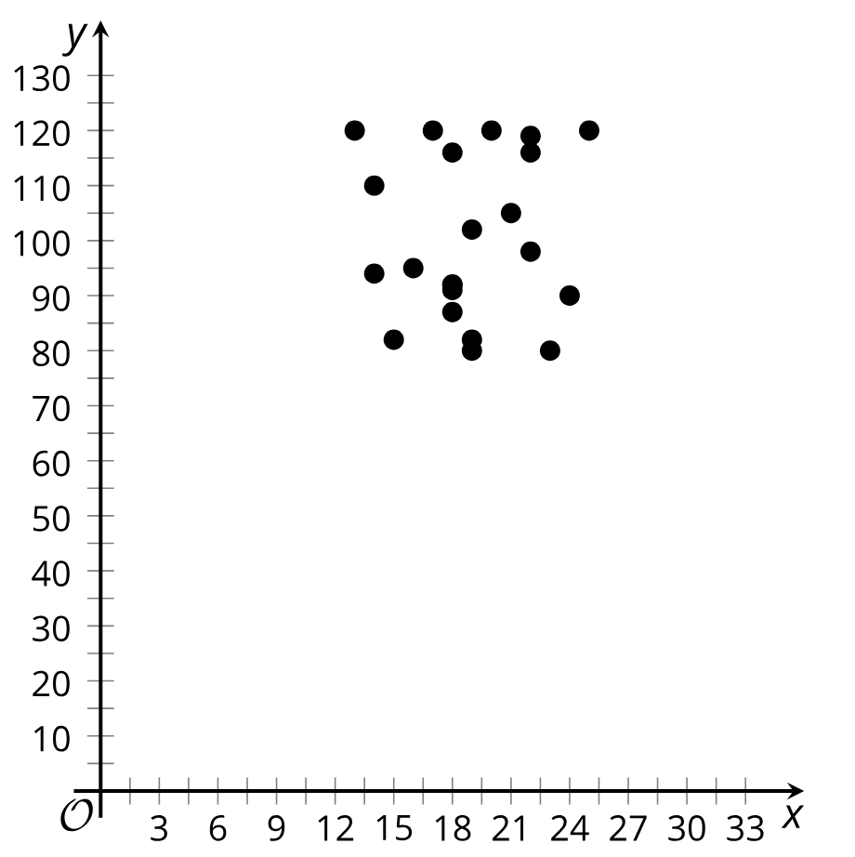 | $$x - variable:$$  Measured student height  in feet  $$y - variable:$$  Measured student height  in inches
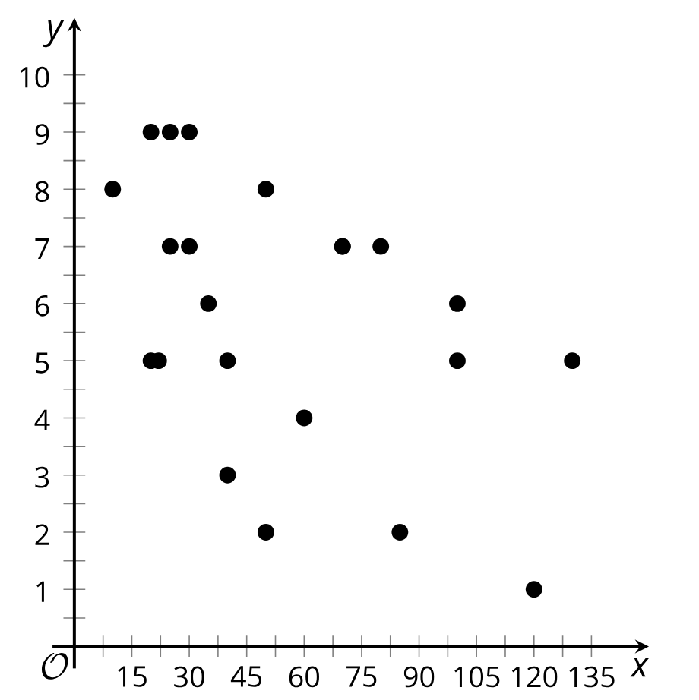 | $$x - variable:$$  Average number of minutes  spent in a waiting room  $$y - variable:$$  Hospital satisfaction rating

